

**GREEN UNIVERSITY OF BANGLADESH**

Department of Computer Science & Engineering

Project Proposal

**COURSE TITEL: Computer Networking Lab**

**COURSE CODE: CSE- 312**

**Date of submission : 05 – 12 – 2020**

Submitted To

# Mohammad Ehsan Shahmi Chowdhury

**Senior Lecturer**

Department of CSE

Green University of Bangladesh

Submitted By

***Md. Parvej Hossain***

ID: 181002085

Section: 181_DC

Department of CSE

Green University of Bangladesh

# **Project Name:** Hospital Management System (HMS)

# **Definition:** A hospital management system (HMS) is a computer or web based system that facilitates managing the functioning of the hospital or any medical set up1. This system or software will help in making the whole functioning paperless. It integrates all the information regarding patients, doctors, staff, hospital administrative details etc. into one software4. It has sections for various professionals that make up a hospital.

## **Benefits of Hospital management System or Significance:**

Hospital management information system is an important tool and means for hospital modern management. It is an important guarantee for hospitals to deepen reform, strengthen management, improve efficiency, and develop harmoniously. It will improve medical quality, promote resource sharing, expand information services, support teaching research, and improve hospitals. Competitiveness and so on are of great significance. Among them, the most important are:

· To optimize the workflow

· To improve the quality of operation

· Shorten the diagnosis and treatment cycle

· To strengthen scientific management

· Saving the cost of diagnosis and treatment

· To change the decision-making method

## **Hospital System Management Diagram:**

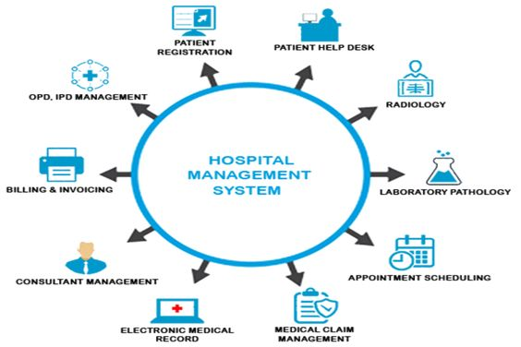

## **Hospital Management System Software Components:**

The hospital information system consists of information systems directly related to medical activities. Including medical expert system, auxiliary diagnostic system, auxiliary teaching system, critical patient monitoring system, drug consultation monitoring system, and some special medical treatment systems, such as CT (computer tomography), B-ultrasound, automatic ECG analysis, blood cells and biochemistry Automatic analysis, etc. These systems are relatively independent, form a dedicated system or are controlled by a dedicated electronic computer, mainly to complete data collection and preliminary analysis work, the results can be compiled into a medical file and medical database through the online network for doctors to query and call. The figure above is a block diagram of the computer diagnostic system. And an information system directly related to hospital management activities. The hospital management information system is mainly aimed at assisting decision-making, with the aim of improving the efficiency and level of hospital management and medical work.

## **Hospital Management System Features :**

(1) Hospital Management System Development

(2) Hospital management system

(3) Sharing documents

(4) Hospital Management System Requirements Manual

(5) Hospital Management System Requirements Specification

## **Hospital Management System Modules:**

1. Medical Appointments Management System

2. Doctor Management System

3. Patient Management System

4. Hospital Pharmacy Management System

5. Administrative System

6. Invoice System

7. Test Lab System

8. Medical Emergency Management System

9. Medical or Doctor’s MIS